**UNIVERSITY OF PUNE**

A PROJECT REPORT ON

**“EMG ANALYSIS AND APPLICATION FOR EXOSKELETON CONTROL”**

BY

**ANUBHAV GUPTA B80383077**

**RITIKA INAMKE B80383064**

**DINESH PATIL B80383080**

Under the Guidance of

**Prof. M. N. ANNADATE**

In Partial fulfillment of BE (Electronics and Telecommunication)

**DEPARTMENT OF**

**ELECTRONICS AND TELECOMMUNICATION ENGINEERING**

**MIT COLLEGE OF ENGINEERING**

**KOTHRUD, PUNE-411038**

**(2013-2014)**



**MAEER’S**

**MIT COLLEGE OF ENGINEERING**

**KOTHRUD, PUNE-411038**

***CERTIFICATE***

*This is to certify that the Project entitled*

**“EMG ANALYSIS AND APPLICATION FOR EXOSKELETON CONTROL”**

*By:*

**ANUBHAV GUPTA B80383077**

**RITIKA INAMKE B80383064**

**DINESH PATIL B80383080**

*is a bonafide work carried out by them, under my guidance, in partial fulfillment of the requirement for the award of Degree of Bachelor of Engineering in Electronics and Telecommunication of University of Pune.*

**Prof. M. N. Annadate Prof. Dr. M T Kolte**

(Internal guide) (HOD of E&TC)

Is approved for the degree of **BACHELOR OF ENGINEERING-E&TC of University of Pune.**

**Examiners: 1. __________________________________________**

**2. __________________________________________**

**Date: Place:**

**ACKNOWLEDGEMENT**

We are exceedingly thankful to the **UNIVERSITY OF PUNE** for giving us a pool of ideas to choose from. Apart from our efforts, the success of this project depends largely on the encouragement and guidelines of many others. We take this opportunity to express our gratitude to the people who have been instrumental in the successful completion of this project.

We would like to extend our sincere thanks and gratitude to our Principal **Prof.( Dr.) V.M.Wadhai** and our Head of the Department, ***Prof. (Dr.) M .T. Kolte*** for providing us the opportunity to present this report.

We are grateful to our project guide ***Prof. M.N.Annadate***, for her guidance and whole hearted support and very valued constructive criticism that has driven to complete the project successfully. We feel motivated and encouraged every time we meet her. Without her encouragement and guidance this project would not have materialized.

We would like to thank ***Mr. Shashi Kumar*** from ***Nasan Medical Electronics Pvt. Ltd .***for providing us the opportunity to be sponsored from such an esteemed organization and for always supporting and guiding us throughout the process.

Also we would like to thank our Project Coordinators ***Prof. R.D.Komati*** from our E&TC Dept. for giving us an opportunity to do this project. We are also thankful to **Prof. Nath, Prof. Danve** and **Prof. Askhedkar** for the encouragement and support in motivating us and providing us guidelines for the completion of the project. We are also grateful to Prof. D.Sherman from Cornell college, for taking out time from his busy schedule and solving our queries over the mail.

Last, but not least, we would like to thank our parents for always encouraging us. We would take this opportunity to thank our friends who were always a source of encouragement.

* Dinesh Patil
* Ritika Inamke
* Anubhav Gupta

**INDEX**

**Chapter No. Description Page No. Abstract 1**

1. **Exordium 2**
   1. Introduction 3
   2. Scope 6
2. **Survey 8**
   1. Survey of related literature 9
   2. Market survey 11
3. **System Specification 13**
   1. Specifications 14
   2. Block diagram 15
   3. Motor driver circuit 16
   4. Intricacies 17
4. **System Design 18**
   1. Designing 19
5. Hardware 20
6. Electrodes 20
7. Preamplifier 21
8. Filters 24
9. Rectifier 27
10. Controller 28
11. Mechanical assembly 29
12. Software 31
13. PCB layouts 32
14. **Implementation 34**
    1. System implementation 35
    2. Algorithm 38
    3. Flow chart 39
    4. Program 41
15. **Performance Evaluation 43**
    1. Performance 44
16. **Applications and Future Scope 50**
    1. Applications 51
    2. Future scope 52
17. **Bill of Materials 53**
18. **References 54**

**LIST OF FIGURES**

|  |  |  |
| --- | --- | --- |
| **Figure No.** | **Description** | **Page No.** |
| 1.1 | Motor neuron attached to a motor unit | 3 |
| 1.2 | Raw EMG signal | 4 |
| 1.3 | Application domains for EMG | 7 |
| 2.1 | EMG analysis for medication and sports medicine | 11 |
| 2.2 | Cyberdyne full body Exo-skeleton | 12 |
| 2.3 | ReWalk Leg Exo skeleton | 12 |
| 4.1 | Surface EMG electrodes | 21 |
| 4.2 | Differential Amplifier for EMG signal | 22 |
| 4.3 | Instrumentation Amplifier using TL064 | 23 |
| 4.4 | 2nd order High-pass and Low-pass Filters built using AD8676 | 24 |
| 4.5 | Passive Twin-T Notch Filter | 25 |
| 4.6 | 2nd Amplifier LMW49990 | 25 |
| 4.7 | Frequency response of high pass section | 26 |
| 4.8 | Frequency response of low pass section | 26 |
| 4.9 | High input impedance Precision Rectifier built using AD8620 | 27 |
| 4.10 | Vigor VS-11 Servo Motor | 29 |
| 4.11 | LabVIEW block diagram for VISA serial EMG acquisition and display. | 31 |
| 4.12 | LabVIEW Signal Display Unit | 31 |
| 5.1 | System input and output | 35 |
| 6.1 | EMG setup and actual captured EMG spike on DSO | 44 |
| 6.2 | PWM signal of 480usec captured on DSO | 45 |
| 6.3 | Servo motor at 0° for no EMG action. | 45 |
| 6.4 | PWM signal of 660usec captured on DSO | 46 |
| 6.5 | PWM signal of 1.5mec captured on DSO | 46 |
| 6.6 | PWM signal of 2.2musec captured on DSO | 47 |
| 6.7 | Servo motor at 180° for high EMG action | 47 |
| 6.8 | Digital board | 48 |
| 6.9 | Analog board | 48 |
| 6.10 | Interface board | 49 |
| 6.11 | Assembled board | 49 |
| 7.1 | EMG Medical Analysis | 51 |
| 7.2 | Muscle Rehabilitation | 51 |
| 7.2 | Muscle Computer Interface | 51 |

**LIST OF TABLES**

|  |  |  |
| --- | --- | --- |
| **Table No.** | **Description** | **Page No.** |
| 1. | Angles of rotation and PWM signals for servo | 37 |
| 2. | Recorded EMG signal Data | 44 |

**ABSTRACT**

The aim of the project is to extract raw EMG signals from the arm and analyze them for the detection of the muscle activity apply them to real world applications such as muscle rehabilitation through the employment of a motion support exoskeleton. Another important concept that is considered while designing such a system is the relation between the EMG signal observed and the actual torque applied by the muscle. Efforts have been made to design and create a cost efficient and accurate instrumentation system for EMG analysis and exoskeleton arm control for support and movement as compared to the existing products in the market. The various elements of such an EMG system are discussed in brief providing a general idea of the application for EMG signal monitoring and exoskeleton control.

**Keywords:** EMG signals, Exoskeleton control, EMG extraction and conditioning.

**CHAPTER 1:**

**EXORDIUM**

**1.1 INTRODUCTION**

Biomedical signal means a collective electrical signal acquired from any organ that represents a physical variable of interest. Such signals like EEG, ECG and EMG can be described as well as differentiated in terms of its amplitude, frequency range and phase. The EMG signal is a biomedical signal that measures electrical currents generated in muscles during its contraction representing neuromuscular activities. Muscle contraction and relaxation is controlled by the central nervous system. The nervous system sends a signal through a motor neuron to a grouping of muscle cells, called fibers. That grouping of muscle cells, and the motor neuron that innervates them, is a motor unit — a basic building block of the neuromuscular system, the smallest functional part of muscle tissue. The signal of the motor neuron causes a chemical reaction that changes the membrane potential l of muscle fibers. If the threshold potential is reached a motor unit action potential (MUAP) occurs, causing the electrical activation to spread along the entire surface of the muscle fiber at a rate of approximately 3–5 m/s.

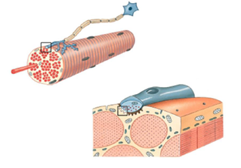

Figure 1.1: Motor neuron attached to a motor unit

The simplest possible explanation is that the EMG signals are the electrical muscle responses to the control signal sent by the brain to initiate the muscle activity. Hence, the EMG signal is a complicated signal and is dependent on the anatomical and physiological properties of muscles.

Electromyography (EMG) is a technique that is used to detect and record MUAPs non–invasively by placing a conductive element (electrode) on the surface of the skin overlying the muscle of interest (this method is referred to as surface EMG) or directly inside the muscle (this invasive EMG detection method utilizes needles or fine wires). Inserted electrodes record from a very small region of muscle, making it possible to view individual MUAPs. On the contrary, surface electrodes tend to record from much larger regions of the muscle. Thus, individual MUAPs are not clearly visible, as many motor units tend to be contracting concurrently. Only the superposition (interference) pattern is recorded. Surface EMG is better for gathering data on: various aspects of behavior; temporal patterns of activity, or fatigue of the muscle as a whole or of muscle groups.

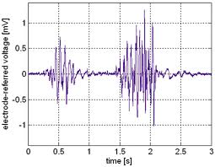

Figure 1.2: Raw EMG signal

An unfiltered and unprocessed signal detecting the superimposed MUAPs is called a raw EMG Signal. When the muscle is relaxed a noise-free EMG baseline can be seen which denotes that there is no action potential of the muscle. The raw baseline noise depends on a number of factors including the environment noise, amplifiers’ internal noise in the circuit and the quality of the detected EMG signal. Assuming a state-of-the-art amplifier performance and proper skin preparation (see the following chapters), the averaged baseline noise should not be higher than

3 – 5 micro volts, 1 to 2 should be the target. By its nature, EMG is purely random which means one raw recording burst cannot be precisely reproduced next time. This is due to the fact that the actual set of recruited motor units constantly changes within the matrix/diameter of available motor units: If occasionally two or more motor units fire at the same time and they are located near the electrodes, they produce a strong superposition spike.

Detection of EMG signals with powerful and advance methodologies is becoming a very important requirement in biomedical engineering. The main reason for the interest in EMG signal analysis is in clinical diagnosis and biomedical applications. The field of management and rehabilitation of motor disability is identified as one of the important application areas. The study of these signals provides us with the information about the muscle activities under different circumstances like muscle strength, force etc. and how do they respond to the received brain signal. The accomplishment of these studies is quite fruitful when someone wants to detect any abnormalities in the muscle movements or simply analyze the signal and apply it to any external hardware like prosthetic hand control, grasp recognition, and human-machine interaction.

The project is aimed at the detection and enhancement of the EMG signals produced by the muscles and using them as a control parameter to assist as well as control motion of any part of the body with the help of an external robotic exoskeleton.

The exoskeleton developed can be used in the rehabilitation field especially the patients who are recovering from a surgery and their muscles tend to be weaker than usual and normally need to undergo physiotherapy to facilitate the muscle movements with original strength and with ease. These weak signals can be detected on the surface of the muscle and based on the characteristics of the signal; the exoskeleton is then controlled to move the joint in time with the patient’s muscle movement.

The basic functioning of EMG signal detection and analysis is as follows:

1. Signal pickup using surface electrodes placed on the muscle.
2. Signal enhancement and filtering to remove noise and unwanted signals.
3. Acquiring the relationship between signal amplitude and muscle force.
4. Moving the exoskeleton providing the required force as also displaying, in real time, the rectified signal as a parameter plotted against time.

Thus, the EMG signal is extracted, signal conditioned and depending on its varying amplitude the control signal is applied to the servo motor, that is the major building block of the arm exoskeleton.

**1.2 SCOPE**

The scope of this project is aimed at the entire range of possibilities of EMG signal analysis as the basic function is detection and analysis of myoelectric signal. Analyzing EMG signals is the core activity related to various medical examinations as well as general sports science studies related to particular muscle activities related to various athletic events and sports.

In medical fields the EMG is used as examination procedure to check on the myoelectric activity and finding out any discrepancies if any. Often the muscle looks undamaged on the surface, however often a torn muscle and its exact ailment can be detected only through an EMG analysis. If extremely deep muscles are to be tested a needle/fine wire electrode may be used. It also finds immense scope in the field of sports science which helps in observing muscle activity and devising appropriate exercises and diets for enhancing the particular muscle action. The advantage of surface EMG is that it can be used during physical activity hence making it an apt choice especially for sports research. Besides basic physiological and biomechanical studies, kinesiological EMG is established as an evaluation tool for applied research, sports training and interactions of the human body to industrial products and work conditions.

As much as the direct application of the project is concerned it finds immediate scope in rehabilitative exercise related to patients recovering from temporary physical disability such as a person involved in an accident with certain muscles damaged temporarily. It also finds immediate use in assisted movement aimed at elderly persons having a fatigue state of muscles. It is can be use d to assist the elderly in challenging physical activities and also be provided as an alternative to various support mechanisms such as crutches and wheelchairs. It also helps maintain proper muscle motion and controlling abrupt muscle activity in cases such as hemiplegia, a case of semi paralysis.

If the movement mechanism is replaced by high power motors or hydraulics, it can be used in the military sector as a soldier assistive high powered exoskeleton. Similar experimental projects have been developed by the army in many countries. It also finds use in the industrial sector for ergonomic labor assistance which helps laborers in carrying heavy loads with little difficulty and also maintaining their spinal cord health despite lifting heavy loads.

Thus, by some minor modifications the project can be developed into various products that can be used not only in medical field but also for military purposes and in sports medicine.

Rehabilitation

* Post-Surgery/Accident
* Neurological Rehab
* Physical(Training) therapy

Medical Research

* Orthopedic
* Surgery
* Gait and Posture Analysis

Sports Science

* Biomechanics
* Movement Analysis
* Athletes Strength Training

Ergonomics

* Analysis of Demand
* Risk Prevention
* Product Certification

Figure 1.3: Application domains for EMG

**CHAPTER 2:**

**SURVEY**

**2.1 SURVEY OF RELATED LITERATURE**

EMG is a science developed in the early part of the previous centuries but left vastly unexplored due to hardware limitations in its detection and pickup. Due to recent advancement in the field and technology, EMG analysis and its applications are an upcoming field supported by various good literatures and experiments.

The major literature related to EMG is in context to the myoelectric signals and the various methods of their detection. Recently a lot of literature research has been carried out in the field of EMG signal as a control parameter in real life based experiments and projects. EMG which was a conventionally considered as a purely research activity is now being brought into commercial and hence a chunk of application oriented literature has surfaced from various EMG system manufacturers such as noraxon, motion lab systems and many other prominent names in the medical field.

The basic part of the literature survey for this project consisted of understanding the basics of EMG and myoelectric signals. The bibles of EMG analysis such as “Muscles alive” by J.V. Basmajian; C.J. De Luca and “Biofeedback” by J.V. Basmajian are the basic stepping stones for venturing into the vast field of biofeedback and myoelectric signals. Various application notes provided by Noraxon, Motion labs and Bortec biomedical were referred to obtain an insight into the actual EMG systems and their design and design considerations. Various books related to biomedical signal processing such as “Biomedical signal processing in neurological applications ” by Elsevier were used as a reference point for deciding the amplification, filtering and other enhancement schemes to be applied.

Various research papers and thesis were studied to understand the actual feasibility and implementation of the project. The various forms of designs from various different papers were compared to come to an optimum choice in selection of the required block diagram and backbone of the system to ensure commercial and economic feasibility of the project. Various types of analysis and signal enhancement schemes were studied from various research papers and the aim of this part of the literature survey was to use the knowledge of previously implemented similar projects to maintain the practicality if and when the project is introduced to the actual application sector. Literature related to similar products was studied to understand the market feasibility of the projects and specification requirements. It was concluded from these studies that to ensure a successful application as well as market oriented project, it was necessary to maintain the economic practicality for the end user by avoiding unnecessary stages at the same time not over simplifying the concept ending up with an inaccurate measurement system.

Based on the study of various literatures the components and IC’s were selected to gain the optimum performance keeping in mind the different noise considerations. Thus, the literature survey brought light on the following aspects essential to the project completion cycle layout:

* Basics of EMG and myoelectric signal activity in relation to the muscle.
* EMG signal detection and enhancement parameters and various factors to be considered for accurate measurements.
* Complexities involved in the system design and the various factors for avoiding spurious signals from corrupting the output signals.
* Surveying the required type and specifications of components for the system hardware design.
* Suitable software for system designing and simulation.
* Types and specifications of the mechanical assembly for the exoskeleton structure.

**2.2 MARKET SURVEY**

1. **Analysis oriented products:**

These products are oriented towards patient analysis and medical research in hospitals and rehabilitation sensors. Besides medical research and studies, such products are also used in the sports research segment aimed at training of athletes and surveying the results of various diets/food products on the muscles.

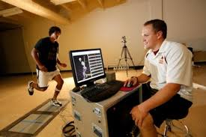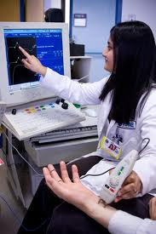

Figure 2.1: EMG analysis for medication and sports medicine.

1. **Application Specific Products:**

While the image of Iron Man rocketing across the sky is immediately compelling, that kind of integrated flying exoskeleton remains a long way off. But still exoskeletons are becoming popular day by day in the field of rehabilitation and are being produced by leading companies as an assistance to body movements.

Robot Suit HAL (Hybrid Assisted Limb) is a 'cyborg-type robot' that can be used to replace limb function or expand and improve a person's physical capability and wellbeing. When a person attempts to move, nerve signals are sent from the brain to the muscles through motoneurons. This moves the musculoskeletal system as a consequence. Weak bio-signals can be detected on the surface of the skin and HAL catches these signals through a sensor attached on the skin of the wearer. Based on the signals obtained, the power unit is then controlled to move the joint in time with the wearer's muscle movement. Cyberdyne and Tsukuba University began hospital trials of the HAL suit in 2012 in Japan. By October 2012 HAL suits were being used by 130 different medical institutions across the country.

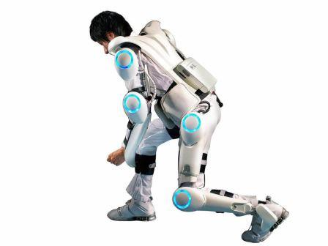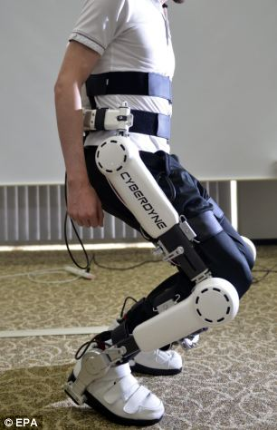

Figure 2.2: Cyberdyne full body exo-skeleton

“ReWalk” is a commercial [bionic](http://en.wikipedia.org/wiki/Bionic) walking assistance system, using [powered leg attachments](http://en.wikipedia.org/wiki/Powered_exoskeleton) to enable [paraplegics](http://en.wikipedia.org/wiki/Paraplegics) to stand upright, walk, and climb stairs. The system is powered by a backpack battery, and is controlled by a simple wrist-mounted remote which detects and enhances the user's movements. Designed in [Israel](http://en.wikipedia.org/wiki/Israel), the ReWalk is marketed by Argo Medical Technologies. [Last summer, an English woman named Claire Lomas used the Argo’s-ReWalk device to become the first person to use a robotic exoskeleton to finish a marathon.](http://www.livescience.com/20269-paralyzed-mom-marathon-bionic.html)

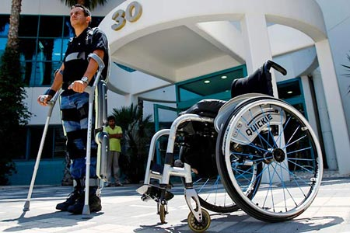

Figure 2.3: ReWalk Leg Exo skeleton

**CHAPTER 3:**

**SYSTEM SPECIFICATION**

**3.1 SPECIFICATIONS**

1. EMG Signal: 0-10mv, 10-500 Hz (maximum energy in the 20-200Hz range).

2. Electrodes: EMG electrodes

Quantity: 3 (two Differential and one reference)

3. Buffer: Impedance matching (OPTIONAL)

4. Pre-Amplifier: Differential instrumentation amplifier (TL064 – Texas Instruments)

With integrator in feedback to minimize AC/DC offset.

5. Filters: 1. Low-pass filter (Cutoff frequency 200Hz).

2. High-pass filter (cutoff frequency 10Hz).

3. Notch filter (49-51Hz to eliminate power supply noise).

6. Rectifier: Precision rectifier followed by an amplifier stage.

7. ADC: 10 bit on-chip (ATmega32U4) ADC.

8. Signal Display and additional filtering and processing using LAB View.

9. Exoskeleton Motor: High torque Servo motor approximately 15-19kgf.cm torque.

Operating voltage: 4.8V-6V

Stall Current: 3.5A

**3.2 BLOCK DIAGRAM**

ELECTRODES

PREAMPLIFIER

BUFFER

(OPTIONAL)

FILTER

RECTIFIER

ANALOG POWER SUPPLYSUSUSUSUSUPPLY

ANALOG TO DIGITAL CONVERTER

MOTOR DRIVER CIRCUIT

PWM

COMPUTER

MICROCONTROLLER

EXOSKELETON MOTOR

DIGITAL POWER SUPPLY

**3.3 MOTOR DRIVER CIRCUIT:**

Power Supply

**CONTROL VOLTAGE**

PWM control signal

signal

SERVO MOTOR

**3.4 INTRICACIES**

1. The major hurdle in designing any medical instrumentation is the extraction of the biomedical signal. Efficient characterization of the signal is needed. Also precise measurement of the signal in presence of the noise interference is the major complexity that is faced more often.
2. Hence, the preamplifier that is designed has a very low amount of offset and noise drift and has a higher degree of noise rejection (CMRR). Precision components having low tolerance values are used (for eg. capacitors, resistors.)
3. Each person will have different body strength and hence their EMG signals will vary in their amplitudes. Also the EMG signal from one particular muscle may be different in terms of its peaks, frequency spread when measured at different instants. In simple words EMG signal is a random signal.
4. The ADC is designed such to take these different values, sample them and then take an average of all the sampled values so as to get one output that is relatively closer to all the values.

**CHAPTER 4:**

**SYSTEM DESIGN**

**4.1 DESIGNING**

There are plenty of sources that can deteriorate as well as some that enhance the quality of the EMG signal partially or fully. The intrinsic factors that affect the quality of the signal are:

* The number of active motor units at any particular time of the contraction, which contributes to the amplitude of the detected signal.
* Fiber type composition of the muscle, which determines the change in the pH of the muscle interstitial fluid during a contraction.
* Blood flow in the muscle, which determines the rate at which metabolites are removed during the contraction.
* Fiber diameter which influences the amplitude and conduction velocity of the action potentials that constitutes the signal.
* Depth and location of the active fibers with respect to the electrode detection surfaces also affects the amplitude and frequency range of the extracted signal.
* The amount of tissue present between the surface of the muscle and the electrode.

These factors cannot be controlled externally in any order to increase the fidelity of the EMG signal. Hence, accurate and precise system design is the only hope which to extract the maximum information from the signal. The extrinsic factors that should be considered are:

* Physiological Crosstalk

Neighboring muscles may produce a significant amount of EMG that is detected by the local electrode site. Typically this crosstalk does not exceed 10-15% of the overall signal contents or isn’t available at all. However, care must be taken to make narrow arrangements with muscle groups

* Change in muscle and electrode distance

There may be a chance of the electrode being misplaced while measurements. Hence, care should be taken to place the electrode at the right position and should not be misplaced as it will alter the EMG measurements.

* Electrodes and Amplifiers

The quality of the signal depends on the selection and quality of the electrodes and internal amplifiers of the circuit.

Hence, the circuit should be less susceptible to noise and must protect the EMG signal’s integrity.

* Real time reactive

As we want the exo-skeleton to move along with the arm, it must move in a flick of a second after the signal has been detected and processed. Hence, the response time of the system should be as less as possible or the processing speed should be higher.

Thus, all of these factors must be considered while designing the system. Let us see each system block in detail.

1. **HARDWARE**
2. **ELECTRODES**

The design of the electrode unit is the most critical aspect of the electronics apparatus which will be used to obtain the signal. The fidelity of the EMG signal detected by the electrodes influences all subsequent treatment of the signal. The electrode shape is defined as the shape of the conductive area. The shape, size and the type of the electrode greatly affects the signal quality and quantity. There are two types of electrodes used for EMG extraction:

* Needle Electrodes.
* Surface Electrodes.

Special medical permission and guidance is needed for the use of needle electrodes. Hence, surface electrodes are to be used recommended for EMG signal extraction at the experiment level. When the size of the electrodes is increased it is seen that the amplitude of the signal increases. But according to the ISEK standards the size of the bipolar electrodes should be large enough to record a reasonable pool of motor units, but small enough to avoid the crosstalk from the other muscles.

The inter-electrode distance also influences the signal pick-up area and crosstalk. Thus, the bipolar electrodes when applied on relatively small muscles, the inter-electrode distance must not exceed ¼ of the muscle fiber length. The electrode material that forms the contact with the skin needs to realize a good skin contact, low skin-electrode impedance and a stable behavior. The electrodes are mostly coupled with “gel” that is used to reduce the skin impedance.

A differential pair of electrodes will be used to detect the muscle contraction of biceps. A reference electrode is generally used along with the bipolar electrodes. It is necessary to provide a common reference to the differential input of the preamplifier. For this purpose, the reference electrode must be placed far from the differential pair and on electrically neutral tissue (say over a bony prominence)

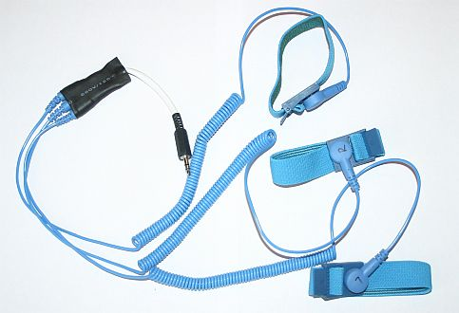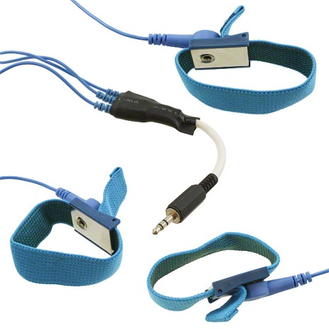

Figure 4.1: Surface EMG electrodes

1. **PREAMPLIFIER**

EMG amplifiers act as differential amplifiers and their main quality item is the ability to reject or eliminate artifacts. The differential amplification technique is shown in the figure. The signal is detected at two sites; the electronic circuitry subtracts the two signals and then amplifies the difference between them. As a result any signal which is “common” to both the detection sites will be removed and signals that are “different” at the two sites will be amplified. Any signal that originates far away from the detection sites will appear as a common signal, whereas signals in the immediate vicinity of the detection surface will be different and hence will be amplified. Thus, relatively distant power lines noise signal will be removed and locally EMG signal will be amplified.

An instrumentation amplifier is used that provides subtraction of the signal along with amplification. The amplifier should satisfy the following criterion:

* Low offset voltage(as the EMG signal amplitude is quite low, the offset must not dominate the signal)

Should not exceed 20µV.

* Low Noise(external and internal noise interferences must be very low)

Typically in nano-volt range.

* High CMRR(the amplifier must be able to reject the common mode signals and amplify only the differential signals)

Typically ≥100dB.

* Low input bias current.
* Low drift(output must not change with temperature or time changes)
* High gain(to amplify signal from micro-volts to volts)



Figure 4.2: Differential Amplifier for EMG signal

The source impedance at the junction of the skin and detection surface may range from several thousand ohms to mega ohms of the dry skin. In order to prevent attenuation and distortion of the detected signal due to the effects of loading, the input impedance of the differential amplifier must be as large as possible. But the requirement of high impedance introduces the problem of capacitive coupling at the input of the amplifier. This small capacitance between the input of the differential amplifier and power line will induce noise in the signal. The solution to this problem is that the preamplifier should be placed as close as possible to the detection surface of the electrode. Such electrodes are called “active electrodes”.

The signal conditioning in analog front ends of medical equipment, such as electromyography (EMGs), presents the additional design challenge of detecting small AC signals in the presence of large differential DC potentials.TL064 OPAMP IC was used to build an instrumentation amplifier. These opamps combine low noise and wide bandwidth with high precision to make them the ideal choice for both dc as well as ac applications. It has high CMRR, low noise, low offset and a high operating slew rate. The integrator or the low pass filter in the feedback loop of the output amplifier is used to reduce the DC offset and AC offset present at a particular frequency.

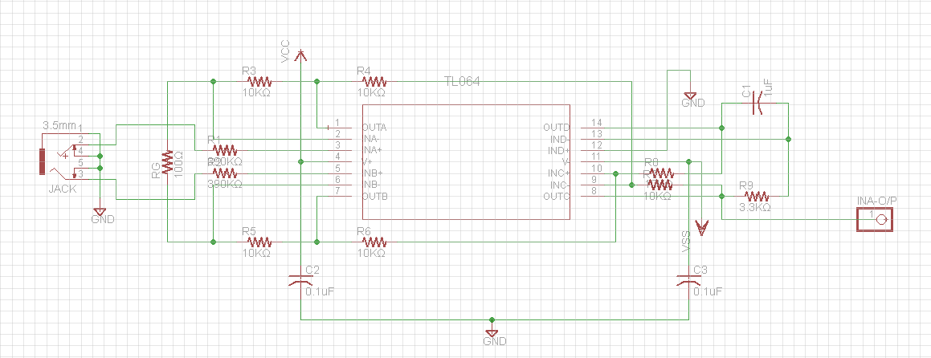

Figure 4.3: Instrumentation Amplifier using TL064

The different ways to get a good response and minimum offset in the output are:

(1) Limit the input gain, G1, to avoid saturation of A1 (1st two buffers in instrumentation amplifier) and A2(differential amplifier);

(2) Implement low-pass filtering in the output stage to remove the differential DC, VD_DC; and

(3) Apply high gain in the output stage, boosting the AC signal of interest, VD_AC.

1. **FILTERS**

The EMG signal acquired by the electrodes is spread in a wide range of frequencies. When the muscle response is to be studied (signal analysis) then the EMG signal should be analyzed in its entire spread. But for only detection of peak amplitude and application to exoskeleton purposes, the entire frequency spread is not much of use. The most commonly observed range of the EMG signal is 5Hz-1kHz, but its most predominant area is 15Hz-150Hz. The filters are designed keeping in view the ISEK(International Society of Electrophysiology and Kinesiology) standards. Hence, the filter design comprises of a low pass filter to remove the high frequency components and a high pass filter to remove low frequency noise.

The Butterworth approximation was used for the filters. It is a type of processing filter designed to have as flat response in the pass band as possible. The order of the filter determines the roll-off rate of it which takes it closer to the ideal response. An ideal response passes the frequencies above/below the cutoff frequency and attenuates all the unwanted frequencies.

Sallen and Key topology was used to design the filter which is known for its simplicity in active filter designing. The design takes into consideration the “Quality Factor” and the “Damping ratio” which is determined by the capacitor ratio. The damping ratio is the factor that decides how early the sinusoidal oscillations die from their peak to zero level.

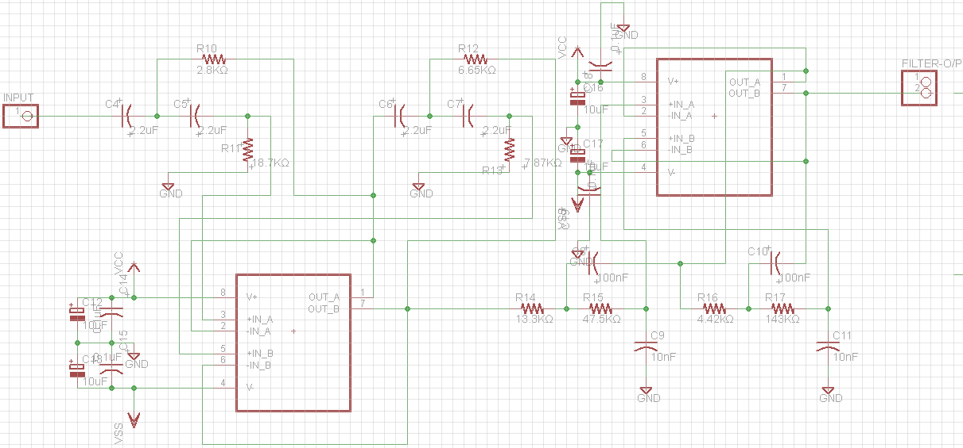Figure 4.4: 2nd order High-pass and Low-pass Filters built using AD8676

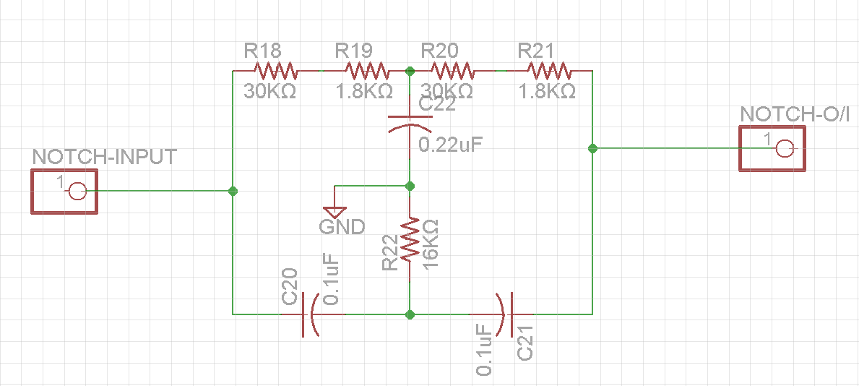

Figure 4.5: Passive Twin-T Notch Filter

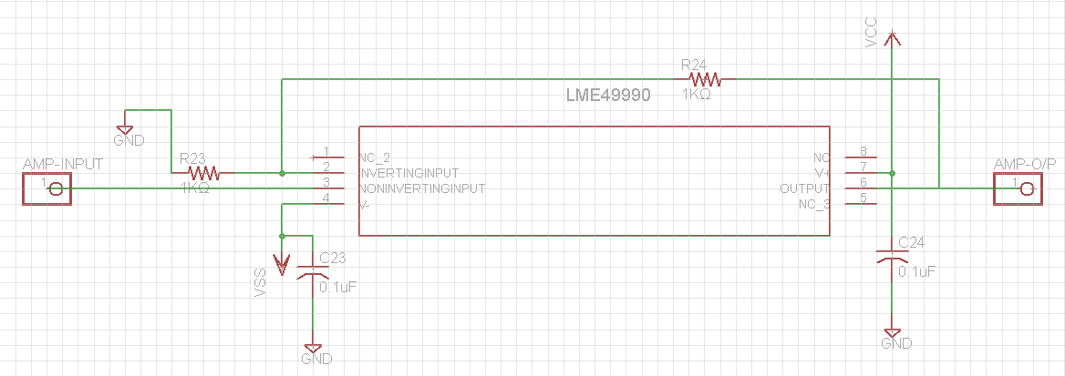

Figure 4.6:2nd Amplifier LME49990

SPECIFICATIONS:

1. High Pass Filter

* Gain=1
* Cutoff Frequency=10Hz
* Stop band Roll off rate= -20dB/decade till 5Hz

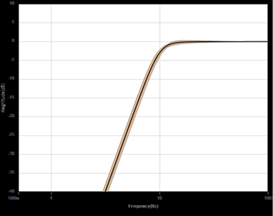

Figure 4.7: Frequency response of high pass section

1. Low pass Filter

* Gain=1
* Cutoff Frequency=200Hz
* Stop band Roll off Rate= -30dB/decade till 500Hz

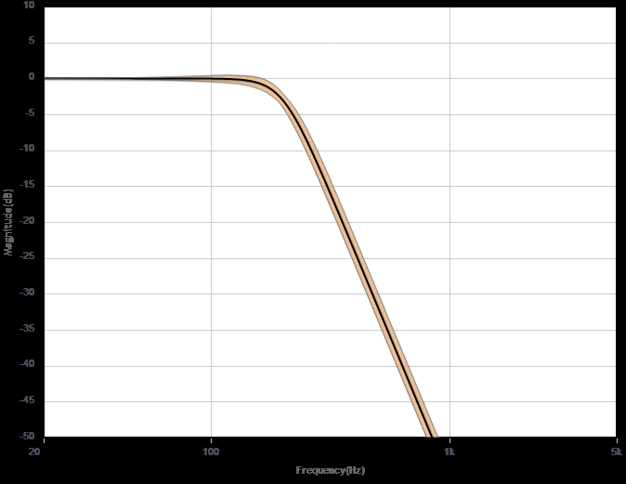

Figure 4.8: Frequency response of low pass section

1. **RECTIFIER**

It is essential that the EMG signal which is captured should only contain positive values so that analog to digital conversion can be performed on it with ease. Because any negative values of the signal will cause the digital signal to go in the negative part of the Cartesian system. Hence, to increase the simplicity of the ADC, the signal is being rectified. Full wave rectification is used as we want the signal in both the cycles and also there will no loss of any information, as in case of half wave rectifier is. The rectification part is not mandatory but if rectified it relaxes the ADC and also calculation of the peak of the signal is simplified.

A precision rectifier that uses a non-inverting amplifier configuration to present high input impedance to the signal is used. Thus we get a positive output for both positive and negative inputs. Since the EMG signal is minuscule and of the order of a few millivolts, a precision rectifier is used to curtail the voltage drop across the diodes.

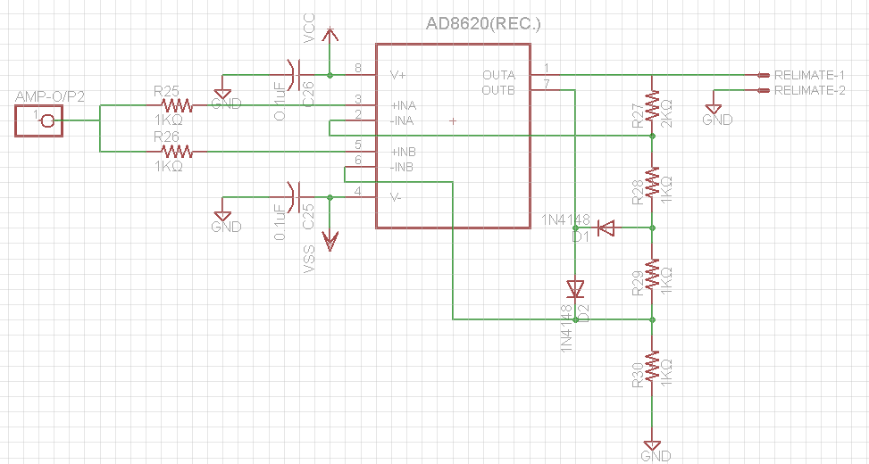

Figure 4.9: High input impedance Precision Rectifier built using AD8620

1. **CONTROLLER**

A micro controller is a small computer on a single integrated circuit containing a processor core, memory and programmable input/output peripherals. Micro controllers are specifically designed for embedded applications. The controller used is ATmega32U4 by Atmel. Some features due to which it was selected are:

* Upto 16MIPS throughput at 16MHz
* Two 16-bit timers with compare mode
* Four 8-bit PWM channels
* On chip 10-bit ADC
* Program burning through USB Flash

The analog rectified signal should now be converted to its digital equivalent in order to communicate with the controller. The ADC used is the on-chip one having 10-bit resolution and uses successive approximation technique for the conversion. The sampling rate of the ADC is 15ksps and the maximum conversion time is 260µs.

The function of the controller is to find out the digital output and generate a PWM signal corresponding to it that will be given to a servo motor. A pulse-width modulated signal is one in which the signal changes from high to low voltage at a specified frequency with the length of the high voltage being the pulse width. The percentage of the wavelength which consists of the high pulse is called the duty cycle. Increasing the duty cycle of the output signal increases the power that the motor receives. A PWM signal is characterized by its duty cycle. A signal having duty cycle 50% will have its ON pulse time equal to the OFF pulse time. Also the current supplied will be the maximum current sourced by the micro controller. While this current can be varied by varying the duty cycle i.e the ON time of the pulse if 30% will supply only 30% of the total control signal. The PWM frequency is chosen to be much higher than the frequency components of the signal. Hence, the motor acts as a low-pass filter, producing an analog response to a high frequency PWM signal.

The exoskeleton is aimed at physiotherapy hence the people that will be using it will have weaker muscle signals. Thus, it must provide greater support when the EMG signal captured is weak and vice versa. So the system designed is such that the motor will move to a greater angle when the signal detected is weak (low) while the motor will move to a smaller angle when the signal is strong (high).

1. **MECHANICAL ASSEMBLY**

The PWM signal generated by the micro controller is given to the servo motor that varies its angle of rotation depending on the control signal. The servo motor is an assembly of four things: a normal DC motor, a gear reduction unit, a position-sensing device (usually a potentiometer—a volume control knob), and a control circuit.

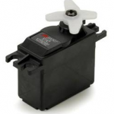

Figure 4.10: Vigor VS-11 Servo Motor

The function of the servo is to receive a control signal that represents a desired output position of the servo shaft, and apply power to its DC motor until its shaft turns to that position. It uses the position-sensing device to determine the rotational position of the shaft, so it knows which way the motor must turn to move the shaft to the commanded position. The shaft typically does not rotate freely round and round like a DC motor, but rather can only turn 180 degrees or so back and forth.

The servo has a 3 wire connection: power, ground, and control. The power source must be constantly applied; the servo has its own drive electronics that draw current from the power lead to drive the motor. The control signal is pulse width modulated (PWM), but here the duration of the positive-going pulse determines the position of the servo shaft. For instance, a 1.520 millisecond pulse is the center position for a Futaba S148 servo. A longer pulse makes the servo turn to a greater angle counter-clockwise from center position, and a shorter pulse to a shorter angle. The servo control pulse is repeated every 20 milliseconds. In essence, every 20 milliseconds you are telling the servo, “go here.”

Servo motor used is VS-11 by Vigor Precision Ltd. Its standard direction of rotation is counter-clockwise and it requires a pulse of width lying between 800µs to 2200µs. It has a minimum torque bearing capacity of 15kgf.cm at 4.8V operating voltage and 19kgf.cm at 6V. The most important factor is that it weighs only a 100 grams which makes it quite portable and comfortable to mount it on the exo skeleton.

1. **SOFTWARE**

The signal is simultaneously transmitted through a serial interface from the controller to the laptop. The real time signal is displayed using LabVIEW software. LabVIEW is a comprehensive development environment that provides engineers and scientists unprecedented hardware integration and wide-ranging compatibility.

LabVIEW’s VISA module is used. VISA is a standard I/O language for instrumentation programming. VISA is a high-level API that calls into lower level drivers. VISA is capable of controlling VXI, GPIB, or Serial instruments and makes the appropriate driver calls depending on the type of instrument being used. One of VISA’s advantages is that it uses many of the same operations to communicate with instruments regardless of the interface type. For example, the VISA command to write an ASCII string to a message-based instrument is the same whether the instrument is Serial, GPIB, or VXI. Thus, VISA provides interface independence. This can make it easy to switch interfaces.

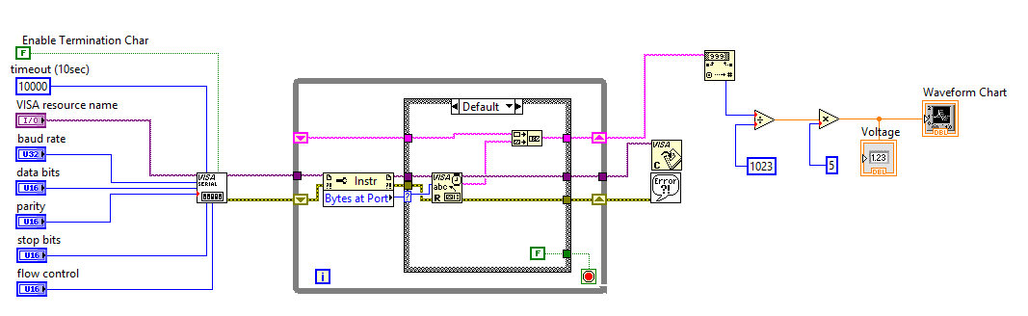

Fig. 4.11: LabVIEW block diagram for VISA serial EMG acquisition and display.

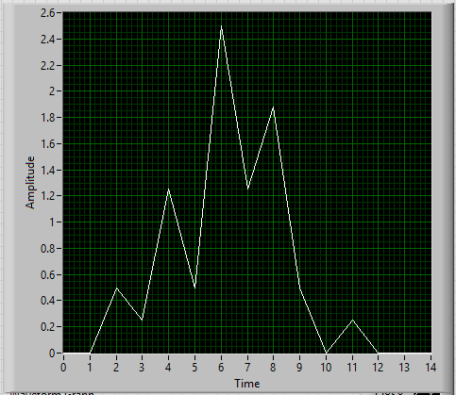

Fig.4.12: LabVIEW Signal Display Unit.

1. **PCB LAYOUTS**
2. **Analog Board:**

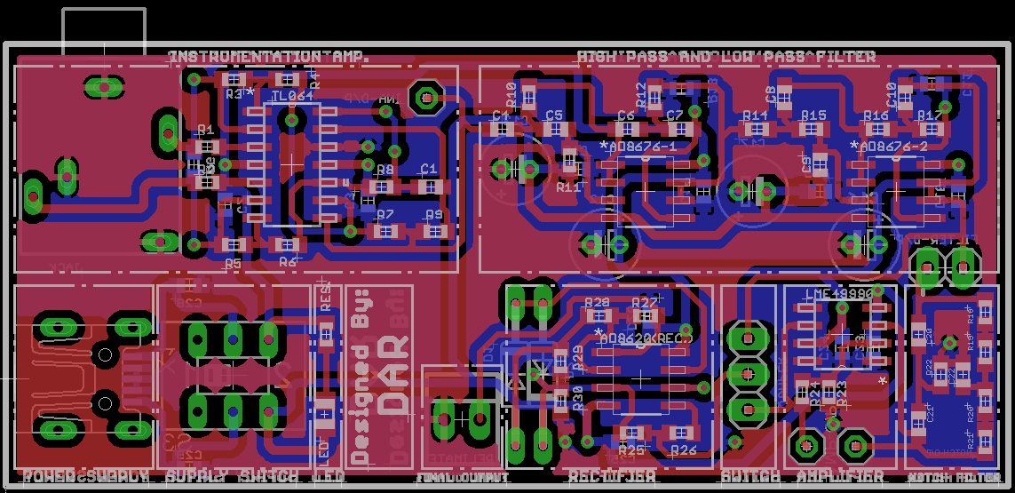

1. 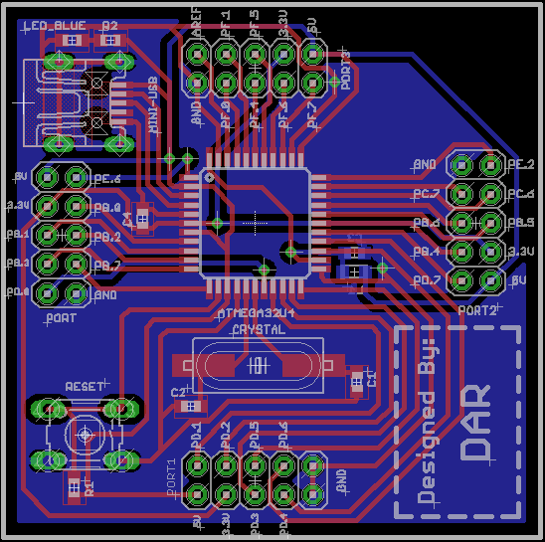**Digital Board:**
2. **Interface Board:**

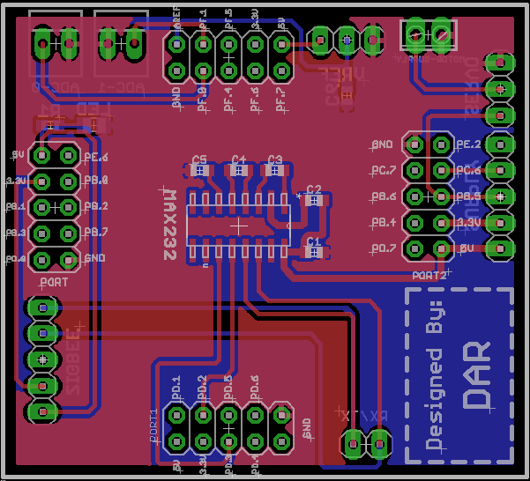

**CHAPTER 5:**

**IMPLEMENTATION**

**5.1 SYSTEM IMPLEMENTATION**

Once the system design is over the next part is to implement it in actual hardware. Also it is necessary to be aware of the appropriate steps that will be followed while implementing the design that will give us the desired output. The figure shown below describes the input to the system and accordingly what should be its output.

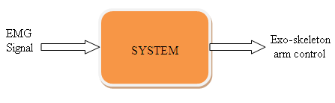

Figure 5.1: System input and output

Surface EMG differential electrodes will be used to capture the signal. It is recommended that the pre-amplifier circuit should be as close as possible to the capturing site of the signal. Because, then the signal won’t have to travel a longer distance and hence has a lesser probability of getting corrupted with noise. Thus, we have made an attempt to keep the analog circuit containing the pre-amplifier to be as close as possible to the detection site. The gain of the preamplifier was set after combining results the from various trial and error iterations. It was seen that with a gain of 201, the preamplifier showed a good response extracting the EMG signal and reducing the surrounding noise. We have already seen the advantage of using differential amplification as it cancels out the noise that is common to both the inputs. The calculation of the gain and the resistance Rg is done according to:

$$Gain=1+\frac{2R_{1}}{R_{g}}$$

The signal is then filtered to discard the higher frequencies and to extract only the information that will be useful for generating the control signal from the concentrated frequencies. The FFT of the EMG signal was studied to out where the signal is exactly centralized. It was seen that the maximum peaks of the signal occurred in the range of 30Hz-150Hz. Hence the filters’ range was selected as 10Hz-200Hz and the harmonics appearing in the rest of the spectrum were discarded. Butterworth Approximation is used as it has a more flat response in its pass band as compared to the other filter approximation types. Band Pass filtering is done with separate high pass and low-pass sections with gain as 1(0dB). An additional notch filter can be added to remove the mains supply noise.

The filters attenuate the signal while discarding the undesired frequencies. Thus the signal is amplified with a gain factor of 2. All the OPAMP ICs that are used were chosen such that they fulfill the basic requirements of low noise, low offset, high CMRR and high slew rate to minimize the noise and increase the desired response of the system.

Next the signal is rectified so as to have positive digital values after digitization. The rectifier used is a precision kind, which is a configuration obtained with diodes and opamp in order to have a circuit behave like an ideal diode and rectifier. The rectifier used is the one having high input impedance and giving a normalized output within a wide range of inputs. All of the analog circuits are powered from an analog supply. Good PCB design guidelines recommend having separate supplies for the analog and the digital parts of the whole system. Thus, preamplifier, filters, rectifier and ADC are powered by an analog supply while the controller is powered by a digital supply. Both the supplies have separate grounds which are connected together at a common point.

The ADC is the bridge between the analog and digital parts of the system. The signal is then sampled by the ADC and converted to digital signal. This is because a digital signal can be easily processed and has less effect of noise that results in low distortion. Also a digital signal can be readily transmitted through a standard interface to a computer as also a processor. ADC’s performance mainly depends on the resolution and accuracy that it offers which is indirectly dependent on the reference voltage. The controller has a provision of an internal voltage reference of 2.56V which is used. Thus the ADC conversion result is as follows:

$$ADC=\frac{Vin×1023}{Vref}$$

Once the controller receives the digital equivalent of the analog EMG signal, then it propagates PWM signal which acts as a control signal to the servo. The servo motor is controlled as follows:

|  |  |  |
| --- | --- | --- |
| **Sr. No.** | **Pulse Width** | **Degree of rotation** |
| 1 | 800µsec | 0◦ |
| 2 | 1.5µsec | 90◦ |
| 3 | 2.2 µsec | 180◦ |

Table 1: Angles of rotation and PWM signals for servo

When the pulse width is 1.5µsecs the motor will move to 90◦ that is considered as the neutral position. Thus the servo angle can be controlled by varying the pulse of the PWM signal. The signal extracted is divided into four intervals based on its amplitude being very low, low, medium and high. Hence when the signal strength is quite low the motor will move to a smaller angle while when it is high enough, the motor covers a greater angle.

**5.2 ALGORITHM**

The algorithm of the code is as follows:

1. Start.
2. Initialize ADC, timer for PWM and USART settings.
3. Set a specified number of iterations (n) corresponding to a limited time interval.
4. Take ADC values continuously for the number of iterations (n).
5. Calculate the maximum ADC value which represents the peak EMG signal value in the time duration.
6. Compare the maximum ADC value with the threshold ranges and find out the PWM value to be set.
7. Set the output compare register (OCRn) to set the appropriate PWM value and hence the angle of the servo motor.
8. Send the collected ADC values through USART for the LabVIEW display.
9. Go to step 3.

**5.3 FLOWCHART**

START

Initialize the system (ADC,Ports,Timer and USART)

According to number of samples needed,

set ‘N’ and start the ADC at n=0, i=0 and MAX=0

Is

n >N

Collect current ADC value and store it in the ADC array at ADC[n]

Is

ADC[n]>MAX

MAX=ADC(n)

n=n+1

Compare the value of MAX with the threshold levels and set OCR register accordingly for the required PWM to set servo angle

Is

i>N

Transmit ADC(i) using USART transmit

i=i+1

Start Again

**5.4 PROGRAM**

/*

* EMG_integrated.c

*

* Created: 3/30/2014 9:25:11 AM

* Author: DAR

*/

# defineF_CPU2000000UL

#include<avr/io.h>

#include<stdlib.h>

#include<math.h>

#include<util/delay.h>

#include<stdint.h>

inti,j;

uint8_tadc_arr[50][50];

uint32_tadc_mean,adc_max;

intmain(void)

{

intsendByte;

CLKSEL0=0x35;// EXSUT1:0=10 ...ALSO ENABLE LOW POWER CRYSTAL AND

//SELECT CRYSTAL

CLKSEL1=0x0F;// EXCKSEL3:0= 1111 ;

UHWCON=0x01;// USB PAD REGULATOR ENABLE.

//General configuration

DDRB=0xFF;

DDRD=0xFF;

//configure ADC

ADCSRA=0x87;//enable adc and prescalar 128

DIDR0=0xf3;

DIDR2=0x3f;

ADMUX=0xE1;//internal vref, LEFT ADJUST and adc1

//USART configurations

UCSR1B=0x18;// Turn on the transmission and reception circuitry

UCSR1C=0x06;// Use 8- bit character sizes

UBRR1=12;

//Configure TIMER1

TCCR1A|=(1<<COM1A1)|(1<<COM1B1)|(1<<WGM11);//NON Inverted PWM

TCCR1B|=(1<<WGM13)|(1<<WGM12)|(1<<CS11)|(1<<CS10);

//PRESCALER=64 MODE 14(FAST PWM)

ICR1=624;//fPWM=50Hz (Period = 20ms Standard).

DDRB=0xFF;//PWM Pins as Out

for(;;)

{

//collect ADC values

adc_max=0;

for(i=0;i<50;i++)

{

for(j=0;j<50;j++)

{

ADCSRA=0xc7;//ADCSRA | 0x40;//ENABLE,SOC AND PRESCALAR

_delay_us(20);

while(!ADIF);

adc_arr[i][j]=ADCH;

if(adc_max<ADC)

{

adc_max=ADC;

}

}

}

adc_mean=adc_max;

/*----------PWM----------*/

//ADC_val=>40=0.1v

if(adc_mean>0xCD) // 0.625 V

{

OCR1A=71;

for(inti=0;i<3;i++)

_delay_ms(500); //180 degree

}

elseif(adc_mean>0x7D) // 0.312 V

{

OCR1A=47; //120 degree

_delay_ms(1000);

}

elseif(adc_mean>0x3C)//0.15V

{

OCR1A=20;

_delay_ms(1000); //45 degree

}

else

OCR1A=14;

//USART____Send ADC values serially to computer.

UCSR1B=0x08;//enable transmission only.

for(i=0;i<50;i++)

{

for(j=0;j<50;j++)

{

sendByte=adc_arr[i][j];

while((UCSR1A&(1<<UDRE1))==0){};

// Do nothing until UDR is ready for more data to be written to it

UDR1=sendByte;

}

}

}

}

**CHAPTER 6:**

**PERFORMANCE EVALUATION**

**6.1 PERFORMANCE**

The EMG signals that was captured by the analog circuitry for different amount of force at different instances are as follows:

Noise at zero signal= 20mV≤ noise ≤50mV

|  |  |  |
| --- | --- | --- |
| **Sr. No.** | **Force** | **Signal Magnitude(Average)** |
| 1 | Very Low | 84mV |
| 2 | Low | 140mV |
| 3 | Medium | 306mV |
| 4 | High | 650mV |

Table 2: Recorded EMG signal Data

The EMG signal after amplification, filtration and rectification looks something like this:

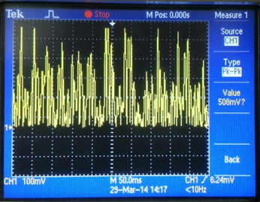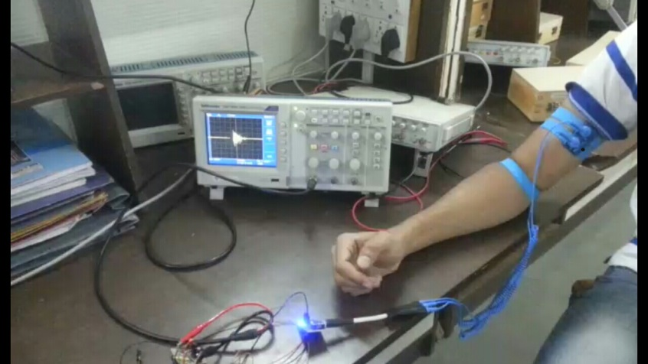

Figure 6.1: EMG setup and actual captured EMG spike on DSO

The PWM control signals for the motor were set at different values as follows:

1. 480 usecs corresponding to 0 degree servo rotation.

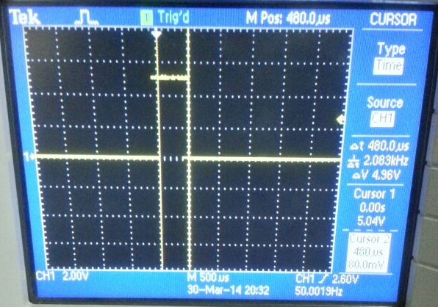

Figure 6.2: PWM signal of 480usec captured on DSO

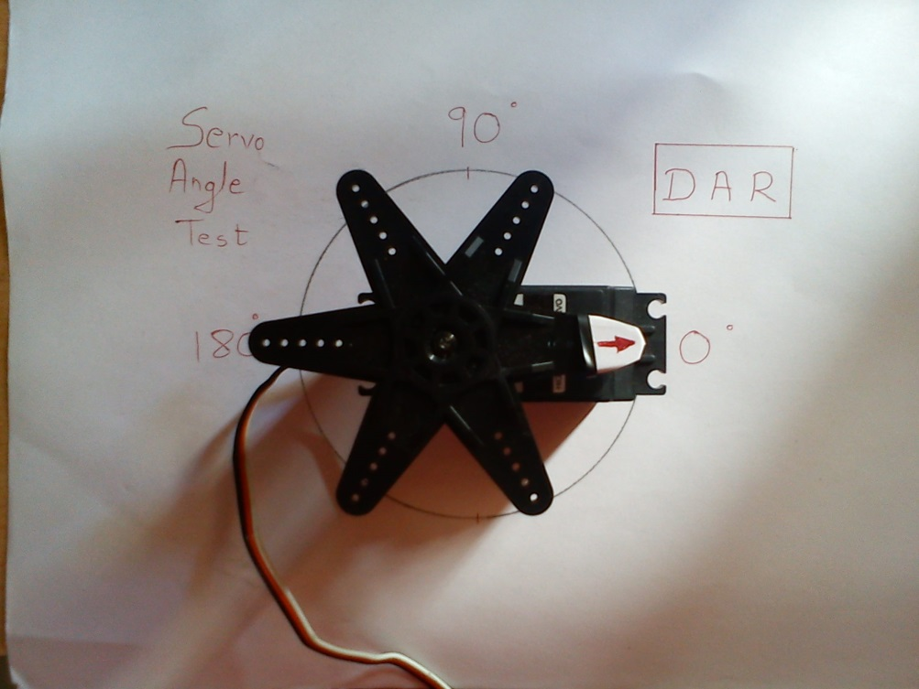

Figure 6.3: Servo motor at 0° for no EMG action.

1. 660µsecs

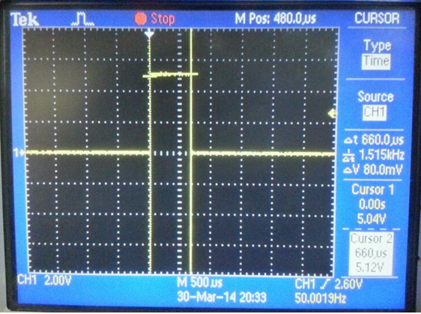

Figure 6.4: PWM signal of 660usec captured on DSO

1. 1.50msecs

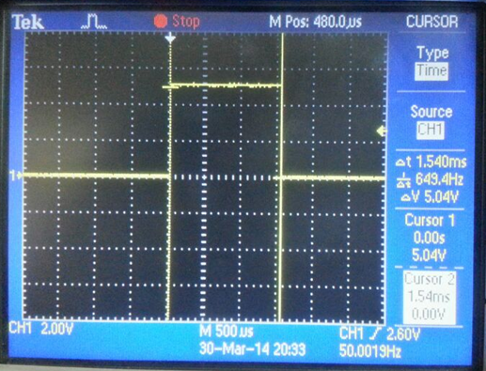

Figure 6.5: PWM signal of 1.5msec captured on DSO

1. 2.20msecs corresponding to 180 degree servo rotation.

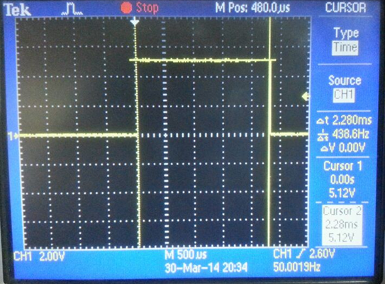

Figure 6.6: PWM signal of 2.2 msec captured on DSO

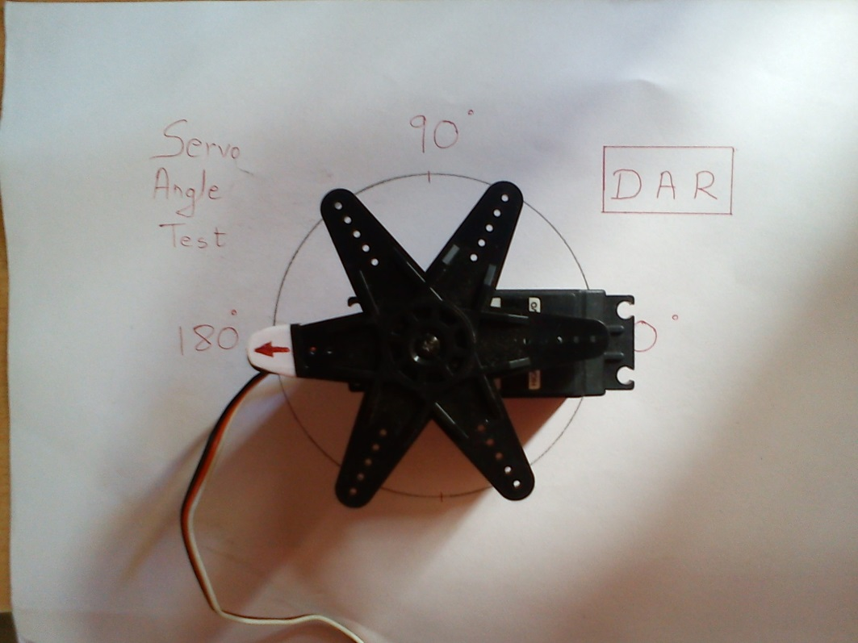

Figure 6.7: Servo motor at 180° for high EMG action.

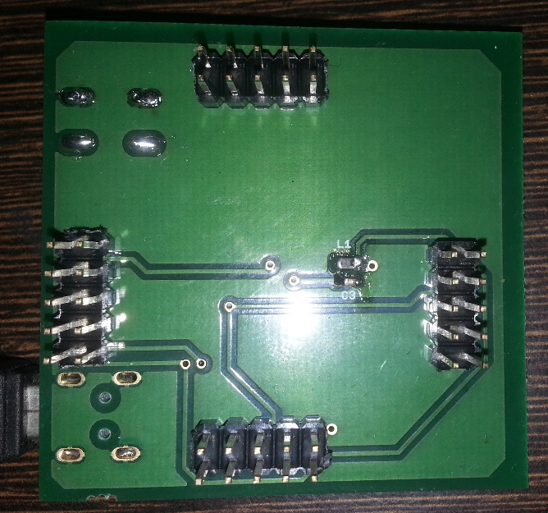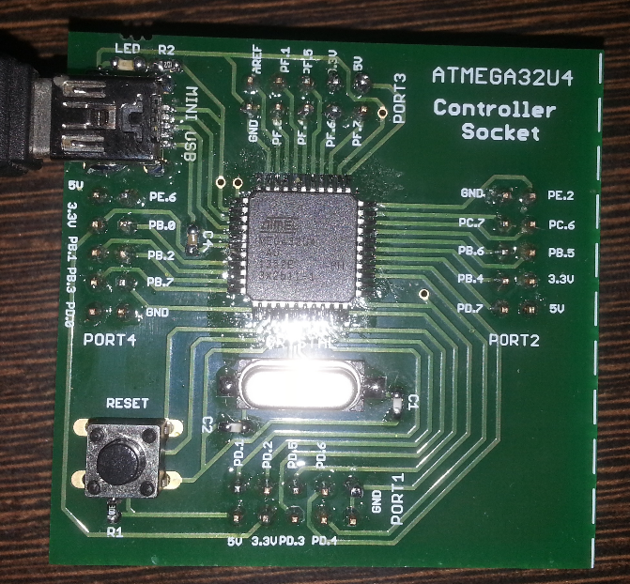

Figure 6.8: Digital board

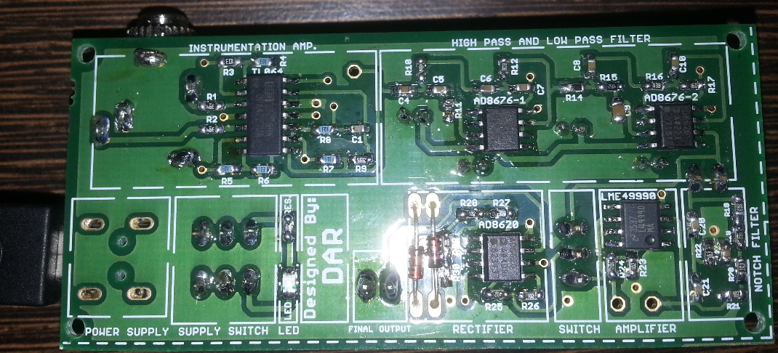

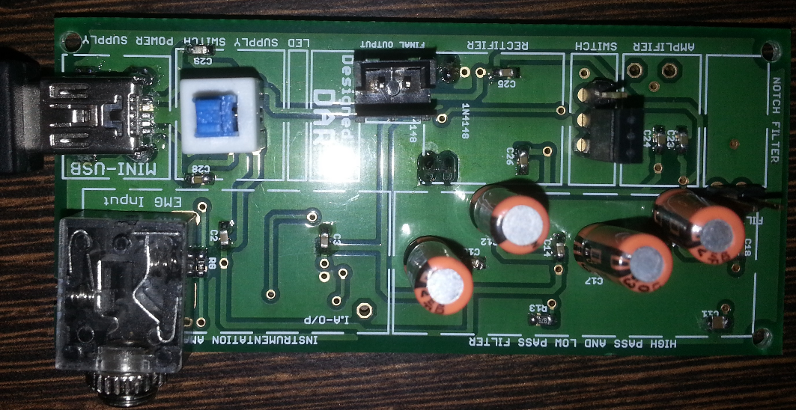

Figure 6.9: Analog board

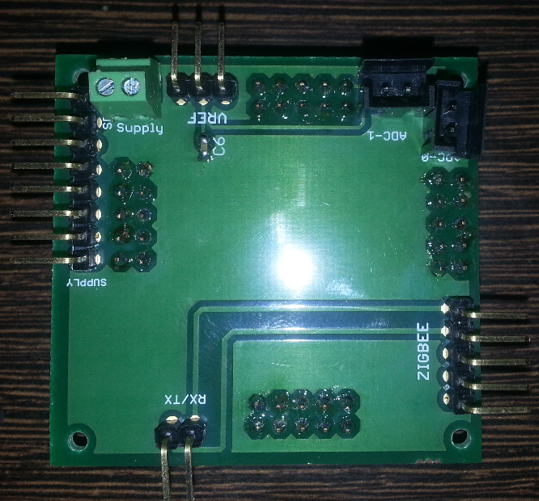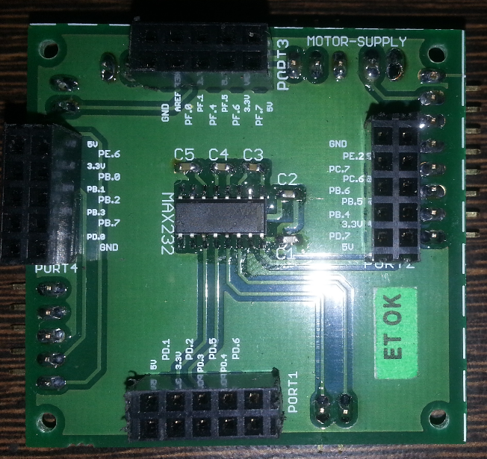

Figure 6.10: Interface board

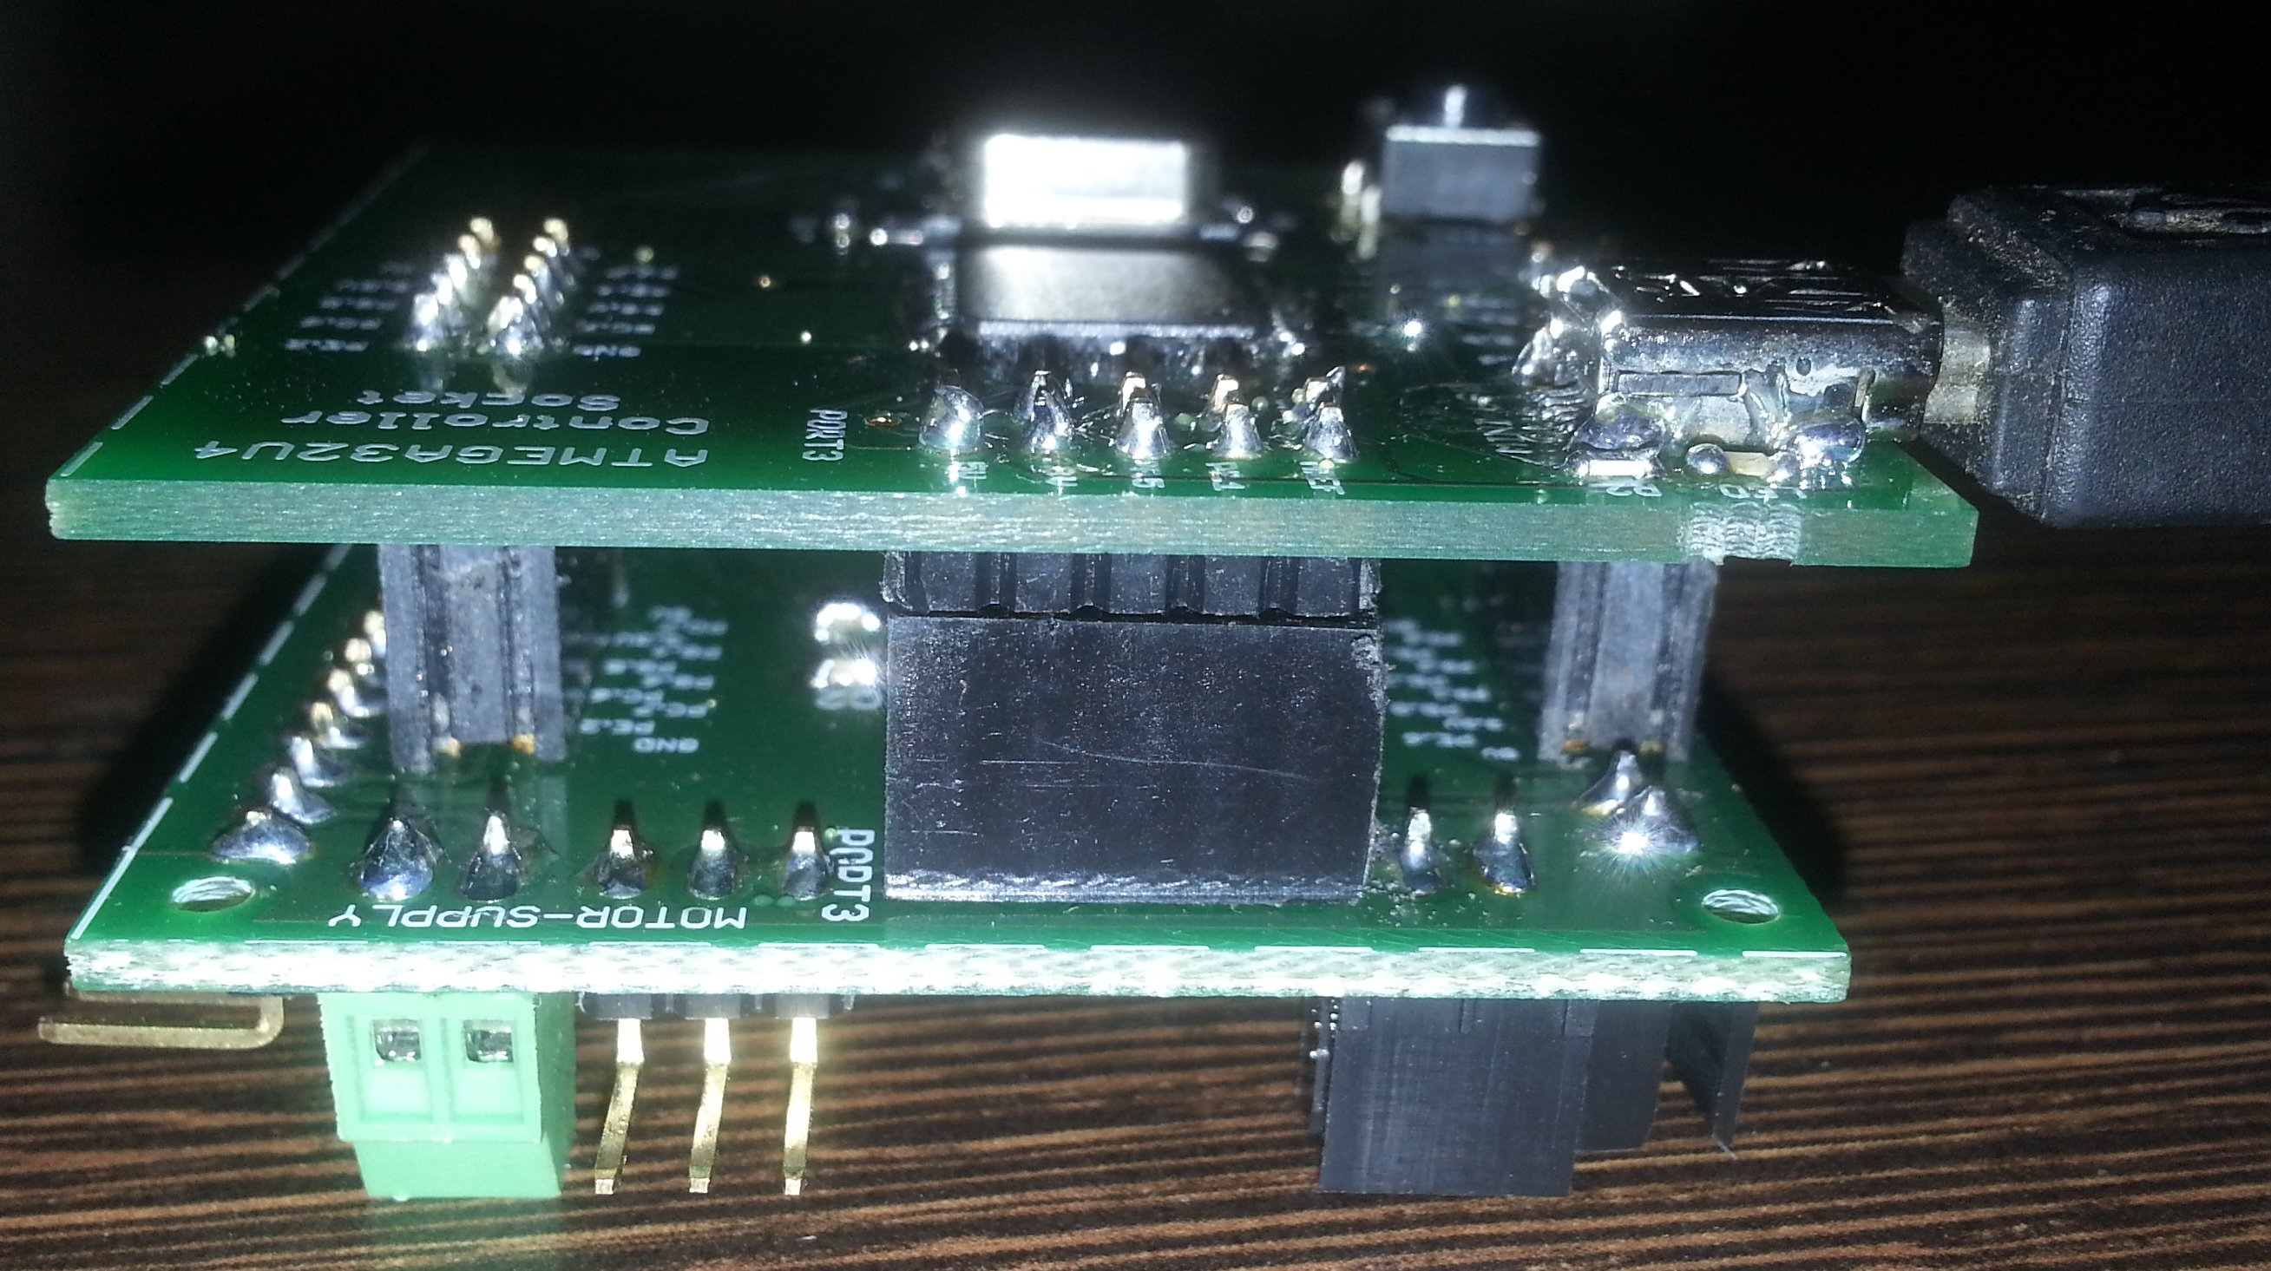

Figure 6.11: Assembled Board

**CHAPTER 7:**

**APPLICATIONS AND**

**FUTURE SCOPE**

**APPLICATIONS**

Due to the dynamic nature of the system it finds applications in various fields of medical research and engineering. The following are the major applications of the project:

1. 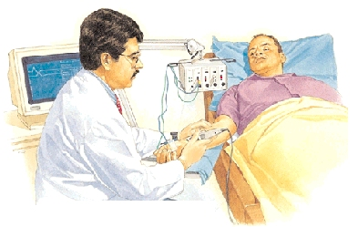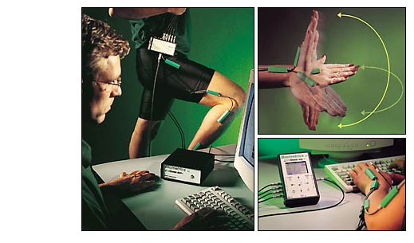**Medical analysis and research:**

Study the disorders and abnormalities related

to muscle movement. Real time muscle

activity analysis as well as stored portable

analysis can be implemented.

Figure 7.1: EMG Medical Analysis

1. **Muscle rehabilitation:**

Provide support and muscle movement force for helping patients recovering from a muscle injury or any other muscle disorder.

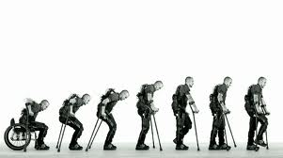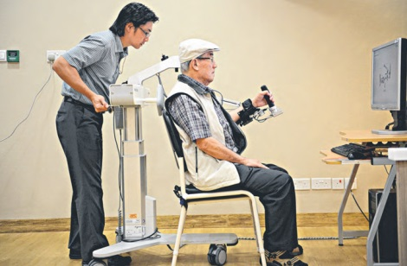

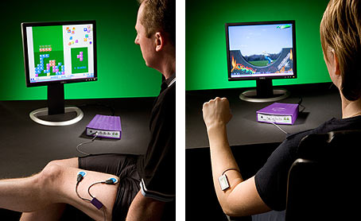Figure 7.2: Muscle Rehabilitation

1. **Human computer interface:**

* Providing a link between human reflexes and

computer programs to create a link between

the two and create an interactive environment

for user input.

Figure 7.3: Muscle Computer Interface

1. **Sports science research:**

Study various muscle activities related to any specific sport to procure an optimum muscle response.

**FUTURE SCOPE**

EMG analysis and Exoskeleton support is a technology which is growing fast and maturing by the day. The type of functionality of the exoskeleton depends on what you want it to do and to what degree you want it to be autonomous. "Outer skeleton", exoskeletons are common in nature. Grasshoppers, cockroaches, crabs and lobsters have exoskeletons rather than an inner endoskeleton like humans, providing both support to the body and protection against predators. Turtles and tortoises have both an inner skeleton and an exoskeleton shell.

Similarly, robotic or mechanical exoskeletons could offer humans the kind of protection, support and strength they afford in nature. Another application is the rescue of victims in case of an earthquake. You need something very flexible in order to intervene rapidly without damaging the victim. The arm exoskeleton that is built in this project thus could be extended to a full body exoskeleton extracting EMG signals of the various muscles where the vital movements are essential.

The system can be made robust to assist the elderly in challenging physical activities and also be provided as an alternative to various support mechanisms such as crutches and wheelchairs. It can also help maintain proper muscle motion and controlling abrupt muscle activity in cases such as hemiplegia, a case of semi paralysis.

If the movement mechanism is replaced by high power motors or hydraulics, it can be used in the military sector as a soldier assistive high powered exoskeleton. Similar experimental projects have been developed by the army in many countries. It also finds use in the industrial sector for ergonomic labor assistance which helps laborers in carrying heavy loads with little difficulty and also maintaining their spinal cord health despite lifting heavy loads.

Thus, by some minor modifications the system designed can be developed into various products that can be used not only in medical field but also for military purposes and in sports medicine. The evolution of the exoskeleton will go hand in hand with the evolution of batteries or other high density storage systems as well as light weight structural materials.

**BILL OF MAERIALS**

1. **Digital Board**

|  |  |  |  |  |  |  |  |
| --- | --- | --- | --- | --- | --- | --- | --- |
| **No.** | **Component**  **Name** | **Manufacturer** | **Description** | **Package** | **Rate** | **Qty.** | **Cost**  **(Tax Inclusive)** |
| **1** | ATmegae32U4 | Atmel Corporation | 8-bit MCU with ISP | SMD, 44-TQFP | 500.00 | 1 | 500.00 |
| **2** | XTAL | TXC | 16MHz,18pF, HC-9-S | SMD | 29.90 | 1 | 29.00 |
| **3** | Mini USB Connector | Hirose | UX60 A-MB-5S8, 5V,1A | SMD | 49.00 | 1 | 196.00 |
| **4** | Resistor(R1) | Vishay | 22R0,100V,1% | 0603 | 6.55 | 3 | 19.65 |
| **5** | Resistor(R2) | Vishay | 22R0,100V,1% | 0603 | 6.55 | 3 | 19.65 |
| **6** | Resistor(R3) | Standard | 1K6,100V,5% | 1206 | 1 | 5 | 5 |
| **7** | Resistor(R4) | Standard | 470R0,100V,5% | 0603 | 1 | 5 | 5 |
| **8** | Capacitor(C1) | TDK | 10uF,6.3V,5%,X5R | 0603 | 9.90 | 2 | 19.80 |
| **9** | Capacitor(C2) | Standard | 10pF,50V,10% | 1206 | 1 | 5 | 5 |
| **10** | Capacitor(C3) | Standard | 10pF,50V,10% | 1206 |
| **11** | Capacitor(C4) | Murata | 22pF,16V,5%,X7R | 0603 | 9 | 5 | 45 |
| **12** | Capacitor(C5) | Murata | 22pF,16V,5%X,7R | 0603 |
| **13** | Capacitor(C6) | AVX | 100nF,16V,5%,X7R | 0603 | 0.9600 | 5 | 4.8 |
| **14** | Inductor(L1) | Taiyo Yuden | 10uF,100mA,10%, 32MHz | 0805 | 9.67 | 2 | 19.34 |
| **15** | Blue LED | Standard | 15mA,Vf=1V | 0603 | 2 | 3 | 6 |
| **16** | Reset Switch | Standard | Push To On | 4 Pin SMD | 6 | 5 | 30 |
| **TOTAL** | | | | | | | 904.24 |

1. **Mechanical Assembly**

|  |  |  |  |  |  |  |  |
| --- | --- | --- | --- | --- | --- | --- | --- |
| **No.** | **Component**  **Name** | **Manufacturer** | **Description** | **Package** | **Rate** | **Qty.** | **Cost**  **(Tax Inclusive)** |
| **1** | Servo Motor | Vigor | Torque:15-19kgcm | - | 1050.00 | 1 | 1050.00 |
| **2** | Mechanical Parts | - | - | - | 500.00 | - | 500.00 |
| **3** | Electrodes | Olimex | - | - | 1500.00 | 1 | 1500.00 |
| **TOTAL** | | | | | | | 3050.00 |

1. **Analog Board**

|  |  |  |  |  |  |  |  |
| --- | --- | --- | --- | --- | --- | --- | --- |
| **No.** | **Component**  **Name** | **Manufacturer** | **Description** | **Package** | **Rate** | **Qty.** | **Cost**  **(Tax Inclusive)** |
| **1** | TL064 | Texas Instruments | High Precision Operational Amplifier | SOIC | 74.00 | 1 | 74.00 |
| **2** | AD8676ARZ | Analog Devices | Precision Operational amplifier | SOIC | 309.00 | 2 | 618.00 |
| **3** | LME49990 | Texas Instruments | Ultra low distortion operational amplifier | SOIC | 217.00 | 1 | 217.00 |
| **4** | AD8620ARZ | Analog Devices | Precision JFET operational amplifier | SOIC | 1020.90 | 1 | 1020.90 |
| **5** | Mini USB Connector | Hirose | UX60 A-MB-5S8, 5V,1A | SMD | 49.00 | 1 | 49.00 |
| **6** | LED | Standard | Blue,15mA | 0805 | 3.00 | 1 | 3.00 |
| **7** | Passive Components | Standard | Resistors (1% tolerance) and capacitors | 0603 | - | - | 160.00 |
| **8** | Precision passive | Vishay | Resistors 0.1% tolerance | 0603 | 50.00 | 4 | 200.00 |
| **9** | Diode | Standard | 1N4148 |  | 3.00 | 2 | 6.00 |
| **10** | Audio Connector | Standard | 3.5mm audio jack connector | Standard | 30.00 | 1 | 30.00 |
| **11** | Connectors | Standard | Relimets,pin headers and jumpers. | Standard | - | - | 50.00 |
| **TOTAL** | | | | | | | 2427.00 |

1. **Interfacing Board**

|  |  |  |  |  |  |  |  |  |
| --- | --- | --- | --- | --- | --- | --- | --- | --- |
| **No.** | **Component**  **Name** | **Manufacturer** | **Description** | **Package** | **Rate** | **Qty.** | | **Cost**  **(Tax Inclusive)** |
| **1** | MAX232 | Texas Instruments | RS232 driver/receiver | SOIC | 73.00 | 1 | 73.00 | |
| **2** | Connectors | Standard | Pin headers, relimets,etc. | standard | - | - | 30.00 | |
| **3.** | Passive components | Standard | Resitors and capacitors | - | - | - | 10.00 | |
| **TOTAL** | | | | | | | 113.00 | |

**REFERENCES**

[1] ‘The ABC of EMG’, A practical introduction to Kinesiological Electromyography, Peter Konrad.

[2] ‘Techniques of EMG signal analysis: detection, processing, classification and Applications’, M. B. Reaz,1* M. S. Hussain1 and F. Mohd-Yasin1.

[3] ‘Surface Electromyography’ –Carlo J.De Luca, Delsys.

[4] ‘Important Factors in Surface EMG Measurement’- Dr. Scott Day, Bortec Biomedical.

[5] ‘A Myosignal -Based Powered Exoskeleton System’, IEEE Transactions on systems, MAN, and cybernetics—Part A: Systems and Humans, Vol. 31, No. 3, May 2001.

[6] Inter-electrode spacing of surface EMG sensors: Reduction of crosstalk, contamination during voluntary contractions- Carlo J.De Luca, Mikhail Kuznetsov , L.Donald Gilmore, Serge H. Roy.

[7]Standards for Reporting EMG Data: Dr. Roberto Merletti, Politecnico di Torino, Italy.

[8] Design of an Arm Exoskeleton Controlled by the EMG Signal-Mark Novak, Cornel College PHY312.

[9] Application of Surface Electromyographic Signals to Control Exoskeleton Robots -R. A. R. C. Gopura and Kazuo Kiguchi.

[10]Fuzzy Control of a Robotic Arm using EMG signals, by M. Hidalgo_, G. Tene_, and A. Sánchez_*Member, IEEE*_Departamento de Automatización y Control Industrial, EscuelaPolitécnicaNacionalLadrón de Guevara E11-253, Quito Ecuador.

[11]Design of Wearable, Low Power, Single Supply Surface EMGExtractor Unit for Wireless Monitoring, AnandaSankarKundu1, OisheeMazumder2 and SubhasisBhaumik.

[12]Fundamental Concepts in Signal Acquisition, by Delsys.

[13]The Use of Electromyography in Biomechanics, Carlo J.De Luca.

**WEBSITES:**

[1] [www.wikipedia.org](http://www.wikipedia.org)

[2] [www.ti.com](http://www.ti.com)

[3] [www.analog.com](http://www.analog.com)

[4] [www.atmel.in](http://www.atmel.in)

[5] [www.e2e.ti.com](http://www.e2e.ti.com)

[6] [www.avrfreaks.net](http://www.avrfreaks.net)

[7] [www.ni.com/labview](http://www.ni.com/labview)

**SOFTWARE USED:**

[1] Atmel Studio 6.1

[2] NI LabVIEW

[3] NI Multisim

[4] Atmel Flip 3.4.7

[5] Eagle 6.1

[6] Ultra Librarian

**DATASHEETS**